

**Elinor Warner (Head Teacher)**

**11 School Road, Warstock, B14 4BH**

**0121 474 2356**

**www.hightersheathnursery.org.uk**

**SOCIAL MEDIA**

**POLICY**

**Spring 2018**

**Review spring 2019**

Contents

Linked documents: 3

Scope of Policy: 3

The Law: 4

Dangers and Safety Aspects: 4

Acceptable Use: 5

Intention to Monitor: 5

Responsibilities of all Stakeholders: 5

Sanctions: 6

Documentation and Recording: 6

List of Key Sites: 6

Dos & Don’ts: 6

# Linked documents:

Acceptable Use of Internet

Twitter Policy

e-Safety Policy

Whistleblowing Code

Complaints Procedures

Grievance Procedures

Safeguarding Policies

Data Protection Policy

# Scope of Policy:

Social media is a broad term for any kind of online platform which enables people to directly interact with each other. However some games, for example Minecraft or World of Warcraft and video sharing platforms such as You Tube have social media elements to them.

Highters Heath Nursery School recognises the numerous benefits and opportunities which a social media presence offers. Staff, parents/carers and pupils/students are actively encouraged to find creative ways to use social media. However, there are some risks associated with social media use, especially around the issues of safeguarding, bullying and personal reputation. This policy aims to encourage the safe use of social media by *the school*, its staff, parents, carers and children.

References to Social Media can include (but is not limited to) such sites as:

* Facebook
* Twitter
* LinkedIn
* Instagram
* WhatsApp
* YouTube
* Skype

This list is not exhaustive and any type of digital communication, particularly those which enable information to be sent to a number of recipients simultaneously, will be covered by the principles and procedures as outlined in this policy.

The policy covers use of these methods of communication in school and by all stakeholders in any connection that may have an impact upon Highters Heath Nursery School.

It must be remembered that, whilst a positive benefit may be obtained, use of social media may have effects beyond that originally intended and, for this reason, the dangers and safety aspects are outlined here.

# The Law:

Use of social media websites is covered by legislation; foremost of this is the Data Protection Act 1998. Other relevant legislation includes the Freedom of Information Act and the Human Rights Act.

# Dangers and Safety Aspects:

Social media can be a valuable tool for schools to communicate with parents and other stakeholders, and for pupils to access the global community thus allowing for learning beyond the classroom and local culture. Whilst this may bring many benefits to schools, as to other walks of life, these benefits may be at a price as there are inherent dangers and safety aspects to consider carefully and be aware of.

Dangers may be on a surface level, as simple as loss of productivity of staff as a result of time-wasted spent on social media websites during working hours; equally dangers may be much more serious and involve child protection issues and potential criminal activity.

Dangers may include:

* Breaches of confidentiality, copyright and data protection legislation;
* Breaches of rights to privacy – employees and pupils;
* Reputational harm to the school;
* Damage to employees, pupils, parents and carers, and third party relationships;
* Discrimination;
* Cyber-bullying;
* Harassment;
* Derogatory or defamatory comments made online;
* Airing of controversial views;
* Distasteful information shared about self;
* Slowing down of school IT systems.

Safety aspects involve staff and other stakeholders being aware of the dangers of social media and using the sites responsibly and with due caution, ensuring that they do not expose themselves or others to the dangers as noted above. Social media sites are, by their very nature, open to abuse by those who would wish to create harm but can also inadvertently be a vehicle for malicious intent, or simply for thoughtlessness leading to unforeseen consequences.

# Acceptable Use:

Acceptable use of social media by those within the school community (staff, pupils, parents, governors, visitors etc) should be defined by i) an awareness of the dangers and safety aspects as discussed above; ii) professional boundaries; iii) Ofsted expectations; and iv) Teacher Standards of professional conduct – NB: these standards of conduct should be taken to apply to all staff, not restricted to teaching staff.

Professional conduct will be expected by all staff in their use of social media, whether relating to their conduct in their own time outside of working hours, or during school time. Conduct relating to use of social media sites should always be in line with upholding a professional image and not bringing the school into disrepute in any way. Staff, particularly, should not post any form of complaint or criticism of the school on any social media forum. Equally, their conduct should not give any cause for concern by the school (eg, photographs posted on social media websites etc). Staff should not post photographs or videos of themselves or colleagues which have been taken in school on any form of social media, and should be responsible in determining photographs or videos that have been taken outside of school - refer to the Teacher Standards regarding behaviour *‘within or outside school’*.

Access to social media sites through the school’s network will not usually be made available and the sites may be blocked.

# Intention to Monitor:

It will be the intention of the school to monitor various social media sites in order to ensure that responsible use is being undertaken by all stakeholders.

# Responsibilities of all Stakeholders:

Other school stakeholders’ use of social media in relation to the school is also covered by this policy:

* Parents should be aware of age restrictions on certain social media sites and ensure that their children comply with this – problems can occur when an incident occurs, social media sites are involved and the matter spills over into school time; we would ask for parents’ co-operation and vigilance in this area.
* Social media sites should not be used by parents or other associated adults, in lieu of the school’s Complaints Procedures, to make derogatory or defamatory comments about the school, decisions made by the school or any member of staff, or any member of staff personally. Failure to adhere to this will result in action being taken against perpetrators.
* Governors should be aware of their confidentiality responsibilities when using social media, and not make any statements that may compromise this requirement.
* Staff should act at all times in a responsible manner which does not bring the school into disrepute, and ensure that their use of social media is consistent with this ethos. Use of social media should be consistent with the requirements of the Teacher Standards for all staff:
  + Consistently high standards of personal and professional conduct
  + High standards of ethics and behaviour, within and outside school
  + Having proper and professional regard for the ethos, policies and practices of the school
  + Having an understanding of, and always act within, the statutory frameworks which set out the professional duties and responsibilities.

# Sanctions:

Failure to adhere to the requirements of the school’s Social Media Policy will be challenged and may have consequences. These consequences will differ, depending upon the relationship to the school: staff who do not use social media within the requirements of this policy will be subject to the school’s Disciplinary Procedures; parents who misuse social media, using it as a forum to air their complaints may be contacted by the school initially, with further action (potentially legal action) being taken, if required.

Derogatory or defamatory comments made by staff which impact upon the school (eg, comments about another school, comments about a member of staff, pupil or other person associated with the school) will result in disciplinary action being taken against the perpetrator.

All breaches of the policy requirements will be recorded and, where appropriate, an investigation will be undertaken.

# Documentation and Recording:

Principles given in this policy will be communicated to all stakeholders via notification and reference to the policy in the school prospectus, on the school website, and reminders issued periodically in school newsletters.

‘Near misses’ of breaches of the principles of this policy and any social media related issues or damage to the school’s reputation or that of its staff should be recorded, risk assessed, and any actions as a result should be noted. This documentation should be retained and used to inform any future revisions of the policy, procedures or practice.

# List of Key Sites:

There are a large number of social media sites beyond the well-known Facebook, YouTube and Twitter. The following is a list of the currently common ones (it must be noted that this list will be very fluid as new sites arise and existing ones become less well-used):

* Facebook
* Twitter
* Instagram
* WhatsApp
* LinkedIn
* YouTube
* Blogging
* Flickr
* Skype
* Pinterest

**Those specifically aimed at children**

**According to** [**https://www.net-aware.org.uk/**](https://www.net-aware.org.uk/) **below are the top 39 social network sites accessed by children. (Feb 2018)**

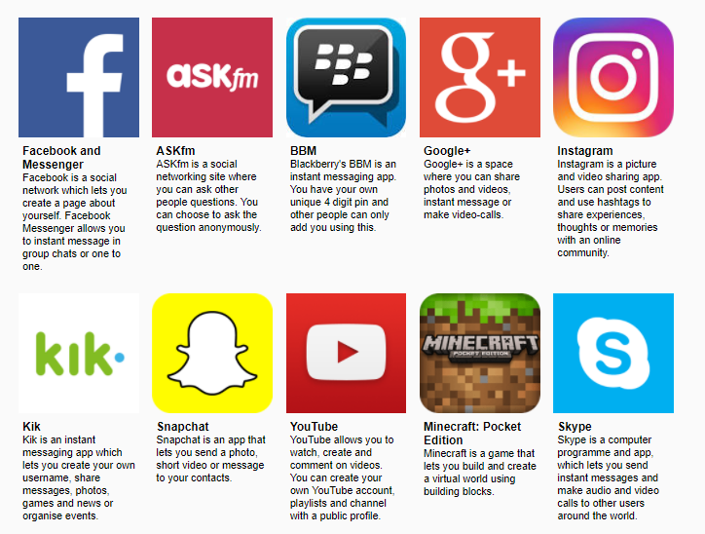

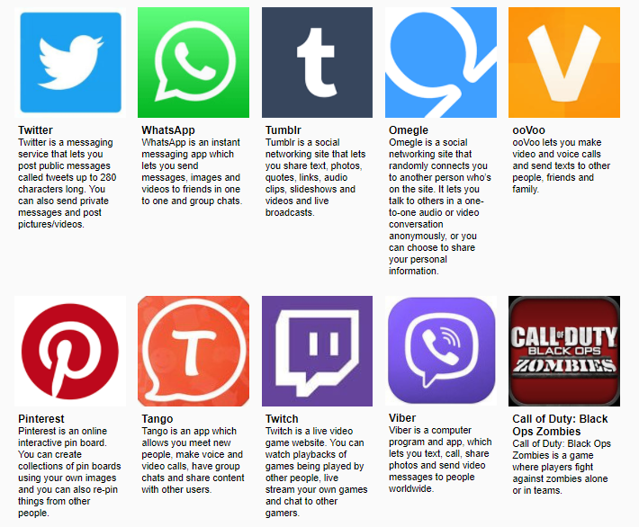

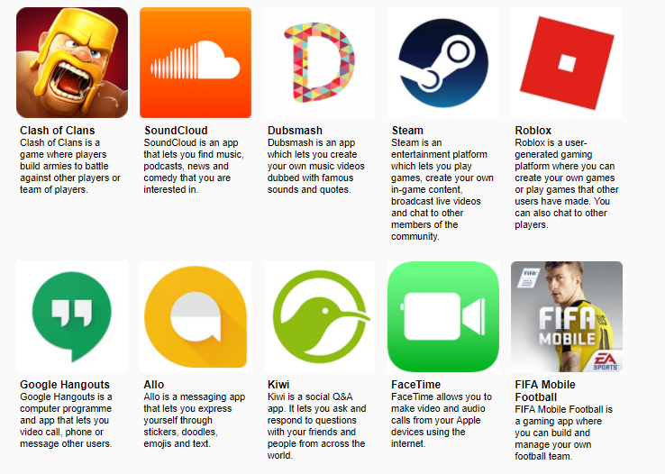

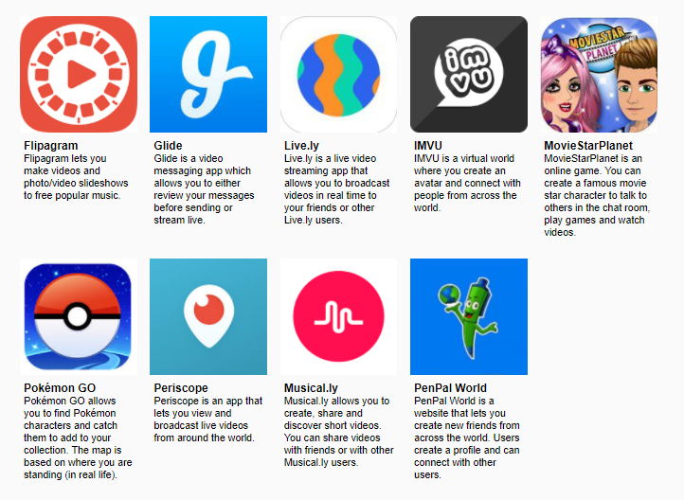

This list is not exhaustive and all networks can be explored by visiting <https://www.net-aware.org.uk/networks/?order=title>

The Computing and Safe Guarding Lead are signed up for regular updates with [www.net-aware.org.uk](http://www.net-aware.org.uk) to help keep abreast with the most popular sites.

# Social media use – pupils and parents/carers

* Pupils may not access social media during lesson time, unless it is part of a curriculum activity.
* Breaches of this policy by pupils will be taken seriously, and in the event of illegal, defamatory or discriminatory content could lead to prosecution, or exclusion.
* Pupils and parents/carers must not attempt to “friend” or otherwise contact members of staff through social media. If attempts to contact members of staff through social media are made, they will be reported to the headteacher.
* If members of staff attempt to “friend” or otherwise contact pupils or parents/carers through social media, they should be reported to the headteacher.
* Pupils and parents/carers should not post anonymously or under an alias to evade the guidance given in this policy.
* Pupils and parents/carers must not post content online which is damaging to the school or any of its staff or pupils.
* Pupils at Highters Heath Nursery School must not sign up to social media sites that have an age restriction above the pupil’s age.
* If inappropriate content is accessed online on school premises, it must be reported to a teacher.

**Be SMART online**

We encourage pupils to take a **SMART** approach to social media behaviour:

**Safe** – Do not give out personal information, or post photos of yourself to people you talk to online. Follow age restriction rules.

**Meeting** – Do not meet somebody you have only met online. We encourage parents/carers to speak regularly to their children about who they are talking to online.

**Accepting** – We advise that pupils only open emails and other forms of communication from people they already know.

**Reliable** – We teach pupils about the dangers of believing everything they see online.

**Tell** – We encourage pupils to tell a teacher, parent or carer if they see anything online that makes them feel uncomfortable.

**Dos & Don’ts:**

**DO:**

Make sure that your Facebook (or other social media) account is set to ‘Private’ so that you control who is able to access your posts and photographs;

Always be aware of your professional responsibilities to the school, and for the example that you give to the pupils;

Ensure that children do not use social media for cyber-bullying purposes;

Always log out of your social media accounts after use!

**DON’T:**

Use social media sites to air grievances against the school or any member of staff, policy, decision or the Governing Body; please use the correct channels as detailed in the Complaints Procedures;

Make any derogatory, defamatory or offensive comments;

Breach Data Protection or copyright laws, or publish information confidential to the school;

Publish photographs of pupils who attend the school on your personal pages or areas such as YouTube – NB, parents who take photographs at school events such as sports’ matches, performances etc, should be aware that, if other children can be seen in the photographs, these should not be published in any arena; any photographs taken should be for personal use only.

**Spring 2018**

**Review spring 2019**

**Approved by the Governing Board :**

**Signed ………………………………………………… Chair of Personnel Committee**

**Date ……………………………………..**